CURRICULUM VITAE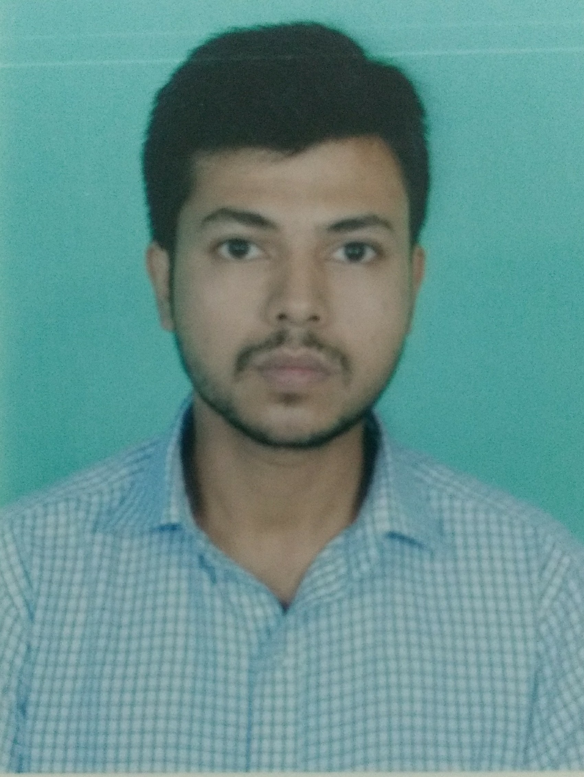

**SUMIT DAS**

**ADYANATH SAHA ROAD**

**PO: SREEBHUMI**

**PS: LAKE TOWN**

**PIN: 700048**

**DIST: KOLKATA**

**Contact no. :** 8961396052



**Educational qualifications:**

|  |  |  |  |  |  |
| --- | --- | --- | --- | --- | --- |
| **Qualification** | **Status** | **Year Of Passing** | **Board/University** | **Institute** | **Marks Obtains** |
| X | PASSED | 2008 | WBBSE | PATIPUKUR ADYANATH SIKSHA MANDIR | 47% |
| XII  (Commerce) | PASSED | 2010 | WBCHSE | | PATIPUKUR ADYANATH SIKSHA MANDIR | | --- | | 61% |
| B.COM (III) | PURSUEING | 2013 | C.U | ANANDA MOHAN COLLEGE | 40% |

**Father’s Name :** DILIP DAS

**Date of Birth :** 28th AUG, 1992

**Nationality :** INDIAN.

**Religion : HINDU**.

**Sex :** MALE.

**known :** BENGALI,HINDI & ENGLISH.

**Hobbies :** CRICKET

**Basic Knowledge :** BASIC & D.F.A.S

**Work Experiences : 1YEAR** IN **BACKOFFICE**

**Place :** Kolkata.

**Date.**

**_____________________**

**Signature**